Exercise 2-3 (15 minutes)
 |  | Product Cost | Period Cost
1. | Depreciation on salespersons’ cars |  | X
2. | Rent on equipment used in the factory | X
3. | Lubricants used for machine maintenance | X
4. | Salaries of personnel who work in the finished goods warehouse |  | X
5. | Soap and paper towels used by factory workers at the end of a shift | X
6. | Factory supervisors’ salaries | X
7. | Heat, water, and power consumed in the factory | X
8. | Materials used for boxing products for shipment overseas (units are not normally boxed) |  | X
9. | Advertising costs |  | X
10. | Workers’ compensation insurance for factory employees | X
11. | Depreciation on chairs and tables in the factory lunchroom | X
12. | The wages of the receptionist in the administrative offices |  | X
13. | Cost of leasing the corporate jet used by the company's executives |  | X
14. | The cost of renting rooms at a Florida resort for the annual sales conference |  | X
15. | The cost of packaging the company’s product | X

Exercise 2-5 (20 minutes)
1. |  | Occupancy-Days | Electrical Costs
 | High activity level (August) | 2,406 | $5,148
 | Low activity level (October) | 124 | 1,588
 | Change | 2,282 | $3,560

Variable cost = Change in cost ÷ Change in activity
= $3,560 ÷ 2,282 occupancy-days
= $1.56 per occupancy-day

 | Total cost (August) | $5,148
 | Variable cost element  ($1.56 per occupancy-day × 2,406 occupancy-days) | 3,753
 | Fixed cost element | $1,395

2. Electrical costs may reflect seasonal factors other than just the variation in occupancy days. For example, common areas such as the reception area must be lighted for longer periods during the winter than in the summer. This will result in seasonal fluctuations in the fixed electrical costs.
Additionally, fixed costs will be affected by the number of days in a month. In other words, costs like the costs of lighting common areas are variable with respect to the number of days in the month, but are fixed with respect to how many rooms are occupied during the month.
Other, less systematic, factors may also affect electrical costs such as the frugality of individual guests. Some guests will turn off lights when they leave a room. Others will not.

Exercise 2-14 (30 minutes)
1. |  | Guest-  Days | Custodial  Supplies  Expense
 | High activity level (July) | 12,000 | $13,500
 | Low activity level (March) | 4,000 | 7,500
 | Change | 8,000 | $ 6,000

Variable cost per guest-day:
Fixed cost per month:

Custodial supplies expense at high activity level | $13,500
Less variable cost element:  12,000 guest-days × $0.75 per guest-day | 9,000
Total fixed cost | $ 4,500

The cost formula is $4,500 per month plus $0.75 per guest-day or
Y = $4,500 + $0.75X

2. Custodial supplies expense for 11,000 guest-days:

Variable cost:  11,000 guest-days × $0.75 per guest-day | $ 8,250
Fixed cost | 4,500
Total cost | $12,750

Exercise 2-14 (continued)
3. The scattergraph appears below.

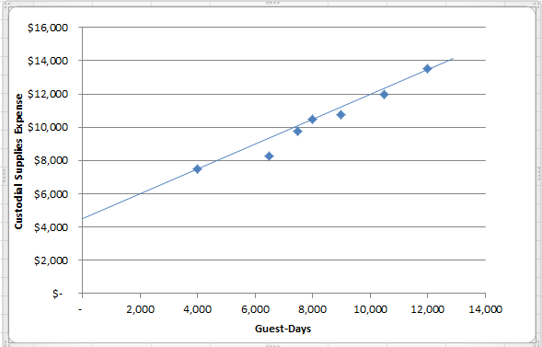

4. The high-low estimate of fixed costs is $526.90 higher than the estimate provided by least-squares regression. The high-low estimate of the variable cost per unit is $0.02 lower than the estimate provided by least-squares regression. A straight line that minimized the sum of the squared errors would intersect the Y-axis at $3,973.10 instead of $4,500. It would also have a steeper slope because the estimated variable cost per unit is higher than the high-low method.

5. Expected custodial supplies expense for 11,000 guest-days:

Variable cost: 11,000 guest-days × $0.77 per day | $ 8,470.00
Fixed cost | 3,973.10
Total cost | $12,443.10

