The Mobiles: Geometry meets Statistics

This project began as an attempt to get statistics into the Math/Art festival, and to get more 3-dimensional pieces and because of a love for Alexander Calder’s work. The mobile is perfect for involving statistics, because balancing is very related to the mean. In starting to plan what would become this lesson, we quickly realized it would involve some geometry also – specifically constant area.
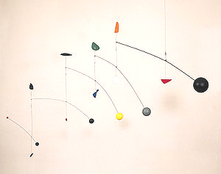

The Math: Statistics

The requirement for these mobiles is going to be that they balance on a level beam. While Calder, of course, made much more complicated balancing arrangements, like in Figure 1, the principle is the same as for balancing a straight beam on the level.

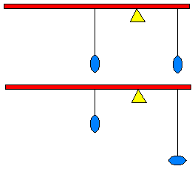Beginning with the basics, it is obvious to most children where to put your finger under a stick so that it will balance. In the middle! The same applies for putting two weights on a beam. If the weights have the same mass, then the balance point should be directly between them. Some questions that may arise include: does it matter how the weights are tied to the beam or does the shape of the weights matter? The answer is almost no. What really matters is the force being applied to the beam and where. Therefore, since the force is the mass times the acceleration of gravity, all that really matters is the mass. But since all that matters is the mass, if one tries this experiment it does not quite work. That is because, of course, the beam and the strings have mass also. This can be mitigated for the experiments by making the mass of the weights much greater than the mass of the beam and string.
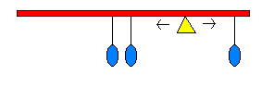
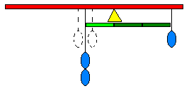
That is all well and good, but two weights do not a mobile make. What happens when a third weight is added? Students have a lot of intuition about this. They will unanimously know that the balance point should move to the left in Figure 4. The question is, how far to the left?

The underlying idea behind the solution is that it is the forces that must balance. In Figure 2, the force needed to hold up the beam in one place is the sum of the two weights directly between them. In other words, the two weights balance there because it is the same as if both weights were suspended from that same spot. Applying this to the three weight beam, it’s as if a double weight is suspended from the average of the two leftmost weights. Then the balance point should be 2/3 of the way from the one weight to the two weights. This intuition is correct, and leads to development of the mean. In fact, the process is very similar to a method elementary students can use to find the mean even before they have division as an operation, often called the hopping method.

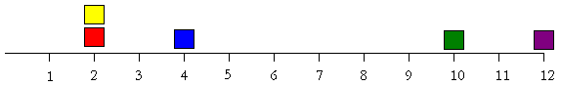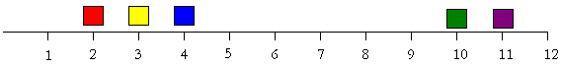Let’s make up a small set of data. The number of times each family member fed the cat this month are: 12, 10, 4, 2, and 2. This can be displayed on a line plot as follows in Figure 4. The question to pose is “What would be a fair number of times for each family member to have fed the cat?” Well, clearly the people (could it be the parents?) who fed the cat 10 and 12 times need to feed the cat less and the 2 and 4 time feeders need to feed the cat more. But each time less the mother, or the 12-time feeder, feeds the cat, someone else has to feed the cat 1 time more. So a marginally more fair distribution would be that in Figure 5. The name of the hopping method comes from that this is like hopping the purple square down one spot, and the yellow square up one spot. This makes sense in the example as it means purple fed the cat one time less, and yellow fed the cat that time. It also makes sense within our traditional computation of the mean, as the mean is the sum of the figures divided by the number of data points. What we have done conserves the sum (2+2+4+10+12 = 2+3+4+10+11) and the number of data points.

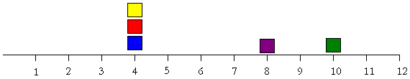We can go on to make the distribution even more fair. Hop the purple square down 3 spots, the red square up 2 and the yellow square up 1. So the cat has not missed a meal or the sum is conserved. What follows are two more equivalent arrangements. Describe what moves are needed to make them. Does the cat miss a meal in either plan?
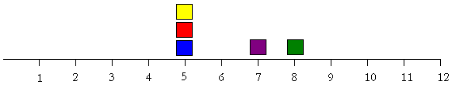
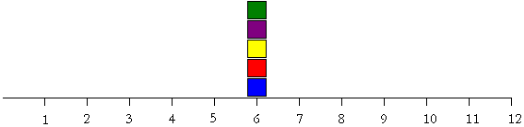
Question:
How does the hopping method apply to the three weight problem in Figure 3?
The Math: Geometry

Since it appears that it is possible for elementary students to understand the math of how to find the balancing point given equal weights, now what was needed was a way to make equal weights visually interesting. The lesson was being envisioned for third graders, and area and perimeter is a big topic in the third grade standards, so the idea of making different shapes of equal area was a natural fit.

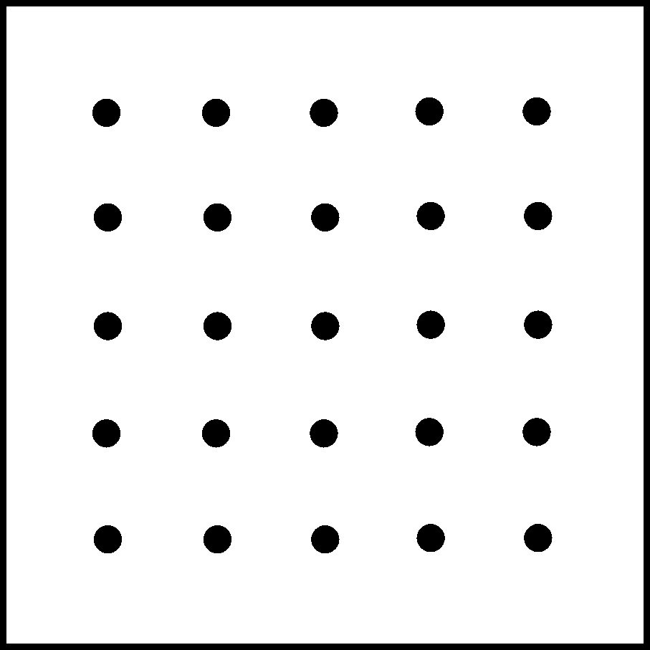
The idea for area that we used was that the area of a shape is the number of units needed to cover it without gaps or overlaps. One setting to introduce this idea is a geoboard. Rubber bands are stretched around the pegs to form objects. Armed with the idea of area above, students will overwhelmingly tend to use the squares on the geoboard as the unit of area. Given an object like that in Figure 8, students will say that it has area six. (Of course, math teachers are honor bound to ask, “Six what?” Receiving an answer of “Six units” or “Six squares”.) After a few examples, the teacher can introduce a shape not composed of unit squares. Such as those in Figure 9.

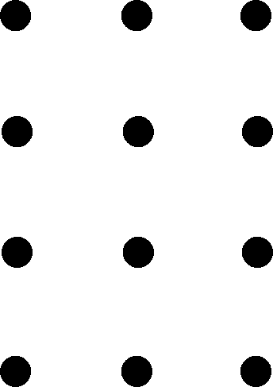
Many students will instinctively begin to cut the shape into pieces to rearrange them. This is an important principle of area, that rearrangement of the pieces does not alter the area, but may lead to confusion and strange calculations for some shapes. The principle that is most useful here is related to that first impulse: the sum of the area of the pieces is the area of the whole. When a figure is divided into pieces, that is partitioning. A related idea is that the area outside the shape can be calculated and used to find the area of the inside, which is called complementing. The relation is that a larger whole is being broken up into the outside and the inside, so that if the area of the whole is known, the area of the inside may be found by missing part subtraction. (The area of the outside plus what gives the area of the whole?)
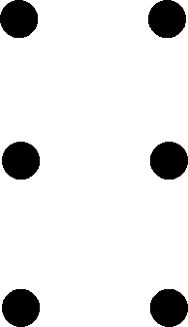
In Figure 9, the area of the right triangle can be found by thinking of it as half of the two square unit rectangle that encloses it. Since the rectangle has an area of 2 squares, the triangle must have an area of 1 square. The concave pentagon from Figure 9 can be partitioned into such triangles of area ½ square, ½ square, 1 square – yielding an area of 2 squares for the whole figure.

Figure 12 contains a quadrilateral that is impossible to partition into half rectangles, but is easy to do by complementing. The entire rectangle has an area of 6 squares, the upper left (green) triangle has an area of 2 squares (it is half of a square with area 4 squares) and the right triangle in the lower right has an area of 1 ½ squares (it is half of a rectangle with area 3 squares.) Then the quadrilateral must have an area of 2 ½ squares, since the three pieces together must add up to an area of 6 squares. Once students discover the complement, they often prefer it to partitioning. It is not too difficult to design a figure whose area is easier to find by using both partitioning and complementing than by using one method alone.

The Art

Alexander Calder was born in 1878 and produce original, groundbreaking art from the turn of the century until his death in 1976. In Paris he combined his training as a mechanical engineer and his interest in art to invent small-scale mechanical toys. Marcel Duchamp instantly dubbed these creations “mobiles” at Calder’s first solo show in Paris in 1932. He went on to create mobiles that ranged from jewelry sized to plaza sized, hanging and freestanding, motorized and wind powered, as well as momentous metal sculptures that he wittily called his “Stabiles”.

Composition: Composition is one of the processes of art. Artists need to take the elements to be included in a work and position them, mentally or physically or both, to create the desired effect. Calder often created the pieces for his mobiles and then physically rearranged them to create a satisfying three dimensional image. He then did the required work to bring the pieces into the physical balance that the mobiles required.

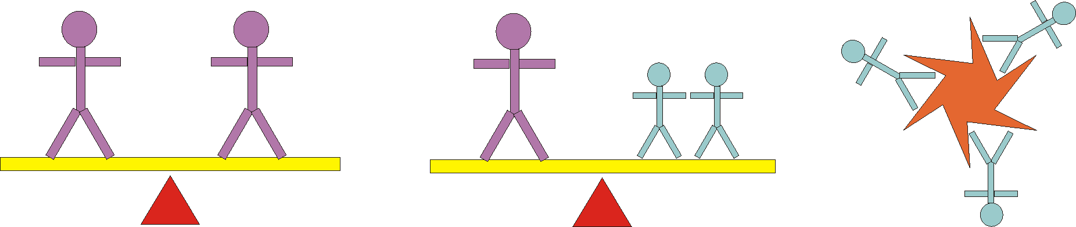
Balance: Balance is a principle of art that relates how artists weigh visual matters. The three most commonly referred to kinds of balance are symmetrical (mathematically having a line of symmetry), asymmetrical (different but balanced) and radial symmetry (mathematically rotational symmetry). These are illustrated below in Figure 13. Artists, of course, can choose to have no balancing also.

The Lesson Plan

Level: 3rd grade

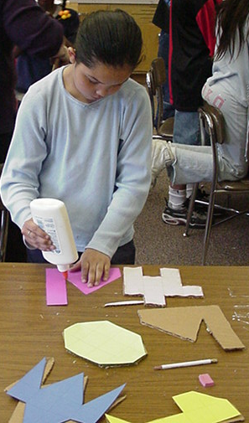
Objectives: Students will learn about area and constant area, and the relationship between the average and balance. Students will learn about the artist Alexander Calder, and the art form of mobiles that he originated. Students will learn about the art concept of balance and process of composition. They will make a mobile of their own, consisting of five differently shaped pieces hanging as they wish from a beam that they arrange and balance.

Context of lesson:
Previous Lessons | Current Lesson | Next Lesson
Area and Perimeter, Mean | Mobiles | Constant Perimeter or further statistics

Materials: (Day 1)
Overhead Projector
Overhead geoboard or blank geoboard transparency
Transparency of geoboard shapes, blank mobile piece design sheets
Geoboards with 2 or 3 rubber bands each, one per student
Geoboard paper, 2 sheets per student
Pencils
Rulers, 1 per student
Box cutters, 1 per student
Grids for constant area shapes, 5 per student + extras for mistakes in a variety of colors
Glue
Heavyweight cardboard (Pizza circles work well, or some large pieces from an appliance store can be cut up.)

Day 1:

Activity | Expected Student Response | Teacher Guidance
Introduction (10 mins)
Introduce the mobile work of Alexander Calder. Display pictures of a few of the works, or perhaps show a real non-Calder mobile. Prompt students for the names for this kind of art, and what is different about it from paintings or other sculptures.  Tell the students that there is a lot of math and science that goes into making this kind of art. Today they will be making the pieces for the sculpture and the next lesson they will be arranging the pieces. Relate this to how Calder worked. | Students may share where they have seen mobiles, or suggest the name “mobile”.  This is 3-dimensional, or not flat.  It can move and most sculptures can not move. | Refer to teachers’ rooms that might have mobiles in them.  If there is a Calder piece in the community, be sure to reference it.  Don’t be shy about putting the mobile into motion.
Launch (10 mins)
Ask the students what they think the area of a shape means in a mathematical sense. Give them a moment to think about it before calling on individuals to answer.  If the mathematical definition is not suggested, introduce it:  “The number of units to cover a shape or region with no gaps or overlaps.” | How much inside a shape  The stuff inside a shape  How big a shape is  How much fits inside a shape  Square inches (or other unit) | You can remind students that an area is a measuring of a shape
Show a 2 x 1 rectangle using an overhead geoboard and elicit agreement about its area. Show other rectangles, including a single square and collect areas.  Show a half of a single square and elicit the area. Repeat for half of a 2 x 1 rectangle and a shape made of two triangles. | Area of 2.  Expect appropriate answers, perhaps some counting mistakes.  Some students may count pegs, instead of squares. | Encourage students to use units. (2 squares.)  It is good spatial reasoning practice for students to copy the shapes you make onto their own geoboards.  Be sure to elaborate on “half of” computations if needed.  Have students share the partitioning on the last shape.
Explore (20 - 25 mins) – If time is an issue, omit this exploration and go to the next.
Display the overhead of the practice shapes to let the students compute their area. | Students can compute the whole squares pieces effectively.  Partitioning may produce triangles that are not half-rectangles.  Students may not think to use complementing on the last shape. | Check over students’ work and encourage them to check against each other.  Remind about partitioning and/or complementing.  If the whole class is struggling with the fourth shape, do a complementing example.
Summary (10 mins)
Review the four shapes. Call on students to explain how they found the areas, drawing from your observations during the exploration | The question can arise about how
Explore (15 mins)
Issue a challenge. Have each student find at least four different shapes all with the same area of 4 squares. | Students will first exhaust rectangles and composite rectangles.  Some students begin with a shape (such as a 2 x 2 square), and think of it as cutting off and taping on pieces. | If they only have rectangles, encourage them to find a non-rectangle.  If they only have shapes made of rectangles, encourage them to make a shape with at least one non-square corner.  Ask students about their strategies for making different shapes.
Summary (5 mins)
Review several different shapes. Be sure to include several that have some non-square corners. | Two examples of creative shapes | If no original shapes have been produced, push the class for how to alter one of the demonstrated shapes. Cut of a square and add it on, remove a triangle and add it on, etc.
Launch (5 min)
Discuss with the class how each of them needs 5 shapes to hang from their mobile. To help with the balancing, we want them all to have the same area. But we want them to have a nice variety of shapes.  Elicit from the students a shape with area of 10 squares. (Either one student can model, or take suggestions from the class.) Ask the students to double check the area. Use a ruler to transfer the design to cardstock.  Cut the shape out from cardstock with scissors. Trace the shape on the cardboard and cut out with a boxcutter. Ask the students for safety rules about using a boxcutter.  Glue the shape to the cardboard. Remind students that they need 5 shapes with area of 10 squares for their mobiles. | There may be questions about the balancing, or the beams.  Add a square there, cut out a triangle, add a half square, etc.  Goggles, being careful, cutting on a cutting board or workbench, never towards a person, safety first.  Does it matter which side we glue on? (Grid or blank.) | Focus the students on the task at hand, making the shapes for the mobile.  If suggestions are boring, ask students how they got interesting shapes before on the geoboard.  What does being careful mean?  Is it okay to cut on the table? Why do we wear goggles?  It is up to the artist.  Remind students not to over glue – a line around the perimeter is sufficient.
Explore (45-60 min)
Circulate as much as possible. List the steps on the whiteboard or on a poster to help students with the process. | First students make five designs on the mobile piece design sheet, double checking the area.  When the designs are approved, let students choose 5 pieces of cardstock, releasing quiet, prepared students first. Make the lines using rulers to help with accuracy.  Students cut their cardstock designs out after double checking the area again.  Students trace the cutout designs onto the cardboard, cutting out the designs once all are traced. | Remind students about 10 squares of area. Encourage original designs.  The teacher may want some check off method as appropriate designs are made. (Both here and on the cardstock.)  Monitor safety issues closely.
Summarize (5 min)
Share nice designs. Make sure that students have their glued pieces together. |  | If there is to be judging, rubber band or sticky note names onto the stack of pieces.

Materials: (Day 2)
Overhead Projector
Transparencies of data sheets for balancing
Pencils
Boxcutters, 1 per student
Rulers, 1 for every group
24 inch balsa beams, one per student
Weights for balancing, 5 per each group. Each made from a lump of modeling clay and a paperclip. The modeling clay can be rolled into balls, and then sorted for mostly equivalent size. As long as it is reasonably close, it need not be perfectly precise.
Student prepared shapes from day 1
Monofilament fishing line, at least 10 feet per student
Hand drills, one per group of students (at least)
Safety goggles

Day 2:
Activity | Expected Student Response | Teacher Guidance
Introduction (5 mins)
Today is the day that the students will complete the mobiles.

Calder often worked by first making his pieces, and then by arranging them. This is called composition. Finally he balanced them.

Today you will first work out some of the math you need for balancing your mobiles, and then
Launch (15 min)
Distribute one balance beam and ruler per group. Explain that the balsa was chosen for being light, but it is not especially strong.  Model how to mark out inch marks on the beam. Some students prefer these to be numbered like a ruler.  Put up the data sheet transparency for the balancing. With the teacher’s beam, attach a weight to the two ends. Ask where the balancing point will be. (At what measure.) Verify by balancing the beam on a finger. Fill in the other columns. Now the question will be: where does it balance if we move the weights? | Some students inch marks will not be regular.  Some students will put the corresponding numbers on marks – that’s totally okay.  Most students will correctly know that it will be in the middle of the two weights. | Caution that materials are scarce, so treat the beam well. This beam will be one of their beams for the mobile.  Encourage students to compare their inch marks to the ruler.  If needed, show how to line up the beginning of the ruler for the last inch mark to mark inches 13 to 24.
Explore (20 min.)
Instruct students to position the weights where indicated on the balance sheet, find the balancing point, and record that and the other data. | Balancing points will vary from group to group | Assist groups that are having difficulty attaching weights  Check to make sure answers are reasonable – if not, look for a procedural or measuring error.  Ask groups that are finished collecting data if they can find a rule to predict where the balancing point will be – especially for the two weight data points.
Summary (15 min)
Collect the groups data on the front board. Ask for a typical balancing point for each weight data set.  Solicit any rules found for determining the balancing point. Ask for group feedback on any different rules.  Ask the groups to figure out where the balancing point should be for weights at 3, 9 and 21 inches to verify. | Students may just pick a middle data point.  The mode will often be suggested if there are a few data points in common.  - Half of the sum for the two weight balances.  - Divide the sum of the measures by how many weights.  - The number of weights times the balancing point is close to the sum. | If desired, the teacher can formally introduce or use the median, which will usually be the best measure for typical with these data sets.  Inquire as to the connection between these different rules. Use a numerical example to help make the point.
Launch (15 min)
Model filling in five weight places and solicit from the class how to find the balancing point.  Mark the balancing point with a big bold line. Ask for the safety rules for the hand drills.  Show how to mark those places on the balsa beams, and drill the holes for the pieces.  At this time the students will also drill the holes through their mobile pieces. Model rotating the piece, trying to decide on a good orientation. The drill hole should go on the top of the desired orientation, about ½ inch from the edge. | Add up the measures, divide by 5.  Goggles, being careful, drilling on a cutting board or workbench, never towards a person, safety first.  Students may feel the pieces should look like they were on the design sheet. (Straight up.) | Discuss how this will determine how spread out or compact their pieces will be on the mobile.  Suggest that students work in pairs, so one can help steady pieces or beams for the other when drilling.  Rotate their pieces to show how different orientations are possible.  This is part of composition.
Explore (25 min)
Ask students to individually fill in the part of the data sheet where assign where they assign the positions for their pieces and calculate the balancing point.  After completing the sheet, drill the beam and the mobile pieces. | Students will probably be free to put them wherever.  Students should turn the pieces to decide which way is up. Pinching the piece in their fingers where they’re thinking about putting the hole allows them to see how it will hang. | Encourage creative placement, but perhaps not too clustered together. Remind students that some of their pieces are pretty large.  If time allows, drilling the mobile pieces can wait until after the composition phase. This allows students to rotate pieces as a part of composition.
Launch (10 min)
When most students are done drilling, gather the class for more modeling.  Lay out your pieces and solicit student comments for composition.  Use monofilament to attach the pieces as composed. | Higher, lower.  Left or right.  Switch the red and the blue. | They can be close or far from the beam.  Remind students that the hanging points are drilled in already.
Explore (15 – 20 min)
Students make the final composition on their mobile | Some students will take no time to consider or rearrange.  Some students will find it hard to commit. | Ask what other arrangements they have tried.  Maybe tie one on, then position the next one.  Why do they like this arrangement?  Do they all have to be the same height?
Summary (10 min)
Lay out all the art so that students can walk around to see. Refer to the voting procedure for selecting the top 3 works. | Students circulate through the art, and write down the numbers of their three favorite pieces. | Discuss before voting the idea of what makes something original.

Voting Rubric
Math | Art | Wow
Constant area pieces?  Level beam? | Interesting pieces?  Color selection – is there a scheme?  Artistic balance  Does the composition show thought or a plan? | How much energy do you feel?  Is it original?

